电脑键盘

**Book8088**

**Instructions for use**

Document Revision 1.0

1. **Introduction to parameters**

IBM PC-XT compatible notebook

8088 CPU

8087 math processor (optional)

640KB memory

IBM CGA Graphics Card (Color Graghic Adapter) 6845 CRT Controller

XT-CF storage adapter

USB controller (CH375B)

OPL3 (YAMAHA YMF262-M) sound card (optional)

ISA-bus-expansion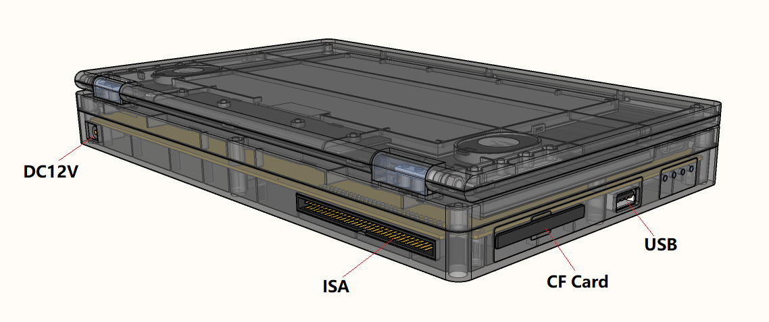

1. **System hotkeys**

**Fn+F1: Turn off the two-channel speaker**

**Fn+F2: Turn on the two-channel speaker**

**Fn+F6: Turn on/off Turbo8Mhz acceleration**

**Disabled (default): The CPU runs at about 4.77MHz**

**On: CPU running frequency 8MHz**

**Fn+F7: quickly input MODE 80 command.**

**(Note: When turning on the computer or exiting the graphics application and entering the text mode, the screen image may move to the right by 1 character. There is a knob on the CRT monitor to adjust, but the LCD does not have an adjustment knob, so you can use the mode80 command to switch the screen to correct, sometimes it may be possible Need to type 4-5 times to recover)**

**Ctrl+Alt+Del: restart**

**3.**Precautions for using the interface

**3-1. The ISA interface needs to be evenly pulled out and plugged in. Do not use force on one end alone to avoid damage to the pins.**

**3-2. The 8087 math coprocessor is a chip that is used for special math operations and floating point operations, and will not be used for other games or software and DOS systems. Moreover, the power consumption of 8087 is very large, which is almost equal to the sum of the power of the whole machine. Therefore, it is recommended that users do not add 8087 chips without using them.**

**3-3. USB storage interface**

**The machine has a built-in ISA-USB controller CH375B, and cooperates with the "CH375DOS.sys" driver file to enable the PC with ISA bus to realize U disk storage.**

**- After entering the system, the system will assign a USB drive letter, such as D:**

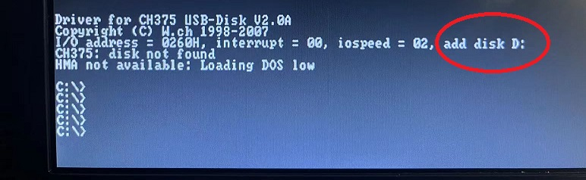

**- After inserting the USB flash drive, enter D: and press Enter, and enter the directory of the USB flash drive**

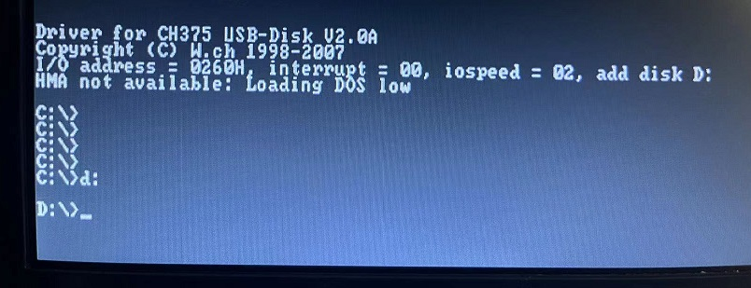

**3-4. Indicator lights**

**CF indicator: Blue-CF card data read and write**

**Red - Turbo mode on (CPU speed 8MHz)**

**CHG indicator light: blue - the battery is fully charged**

**Red - Charging**

**Battery indicator light: Alternate flashing - slow: battery fully charged**

**Alternate flashing - fast: low battery**

1. **common problem**
   1. **Switching between graphics and text modes may cause screen characters to shift to the left when just starting up or exiting the game**

**This is normal, you can enter mode 80 and press Enter. In this way, the system will switch the screen and adjust the position, sometimes it may need to repeat 4-5 times to adjust to normal. As shown in the figure below, the text is offset when the computer is turned on.**

**- After entering the system, enter mode 80 and press Enter**

**- If it is not adjusted well the first time, you can long time interval Then adjust, sometimes need to repeat 4-5 times.**

* 1. **USB not available**

**If the user installs the DOS system by himself, there is no "CH375DOS.sys" in the root directory of the C disk, and the USB driver is not loaded in the config.sys file. You must put the "CH375DOS.sys" file into the root directory of the C drive:**

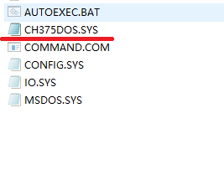 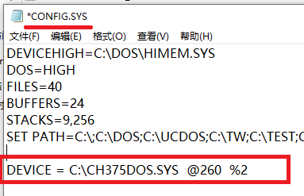

**And add DEVICE = C:\CH375DOS.SYS @260 %2 in the last line of the config.sys file on the C drive**

* 1. **Operation example-view directory-enter directory-exit directory**

**Enter DIR under the current disk and press Enter to view the contents of the current folder, such as C:\> dir**

**Enter the CD directory name to enter the directory, such as C:\> CD GAME (there is a space in the middle)**

**Enter CD.. (two decimal points) to return to the parent directory.**

* 1. **Try to power off when the software is not running or the CF indicator is not flashing, otherwise the file system will be easily damaged**

**If the file system is damaged, the system needs to be reinstalled**

* 1. **Operation example - start Qbasic software.**

**After entering the system, the characters may be shifted to the left. Press Fn+F7 every few seconds to refresh and adjust. If it does not affect the operation, it is not necessary to adjust.**

**-In the C:\ directory, directly enter Qbasic and press Enter**

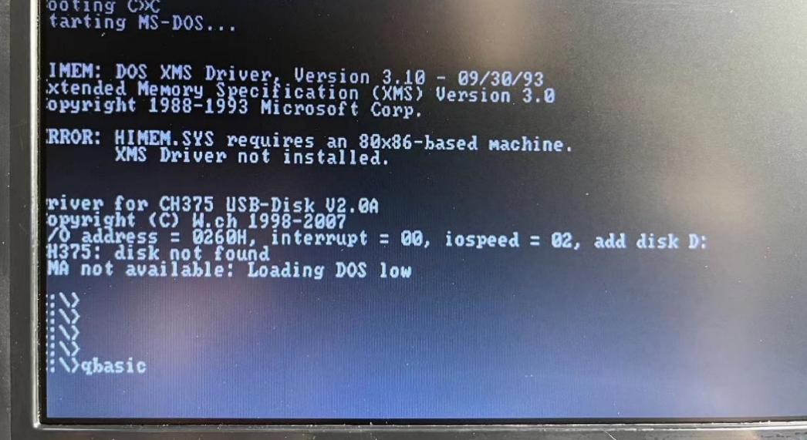

**- When you need to exit, you can press Alt+F to start the menu, select Exit to exit**

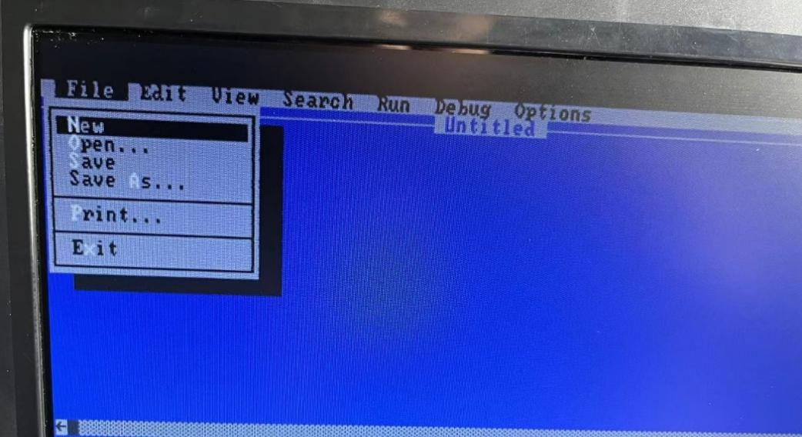

* 1. **Operation example - start the duck game.**

**After entering the system, enter cd game and press Enter to enter the game directory, then enter cd duck to enter the duck directory, and finally enter duck and press Enter to start the duck game:**

**Press the Y key according to the prompt to enter the game**

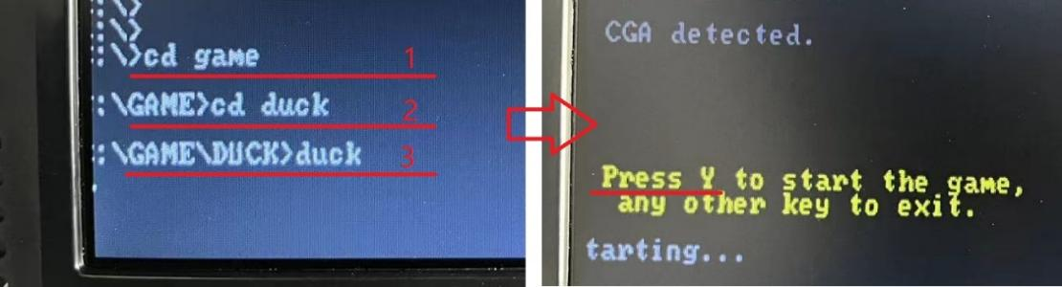

**- Select NEW GAME and then select SLOT 1**

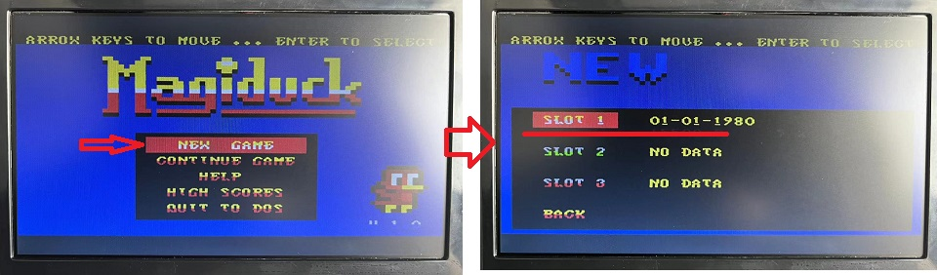

**- Up, down, left, and right can be operated to move, Z key to jump, X key to launch weapons**

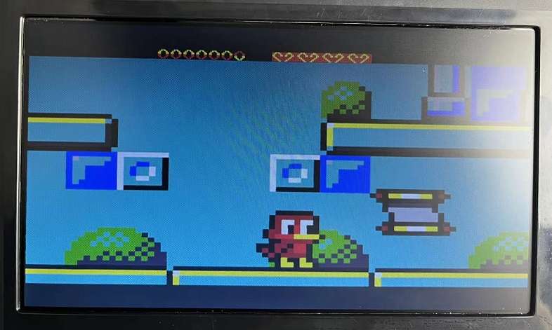

**-Press the ESC key to exit the game, select QUIT TO DOS and then select OK to exit to the DOS system**

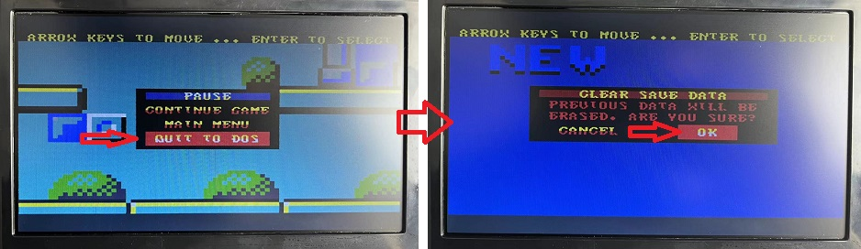

**5. Appendix: Commonly Used DOS Commands**

**DOS command: direct access**

**Directly enter a certain drive letter, drive letter:**

**If you directly enter the D drive, D:**

**DOS command directory command**

**(1) md - create a subdirectory (folder)**

**1. Function: Create a new subdirectory**

**2. Type: internal command**

**3. Format: md[drive letter:][path name]<subdirectory name>**

**4. Instructions for use:**

**(1) "Drive letter": specify the letter of the disk drive to create a subdirectory, if omitted, it is the current drive;**

**(2) "Path name": the upper-level directory name of the subdirectory to be created, if default, it will be built under the current directory.**

**Example: (1) Create a subdirectory named fox under the root directory of disk c; (2) Create a user subdirectory under the fox subdirectory.**

**md c:\ fox (create a subdirectory fox under the current drive c drive)**

**md c:\ fox\user (create a user subdirectory under the fox subdirectory)**

**(2) cd - change the current directory**

**1. Function: change the current directory**

**2. Type: internal command**

**3. Format: CD [/D] [drive:][path]**

**4. Instructions for use:**

**(1) If the path and subdirectory name are omitted, the current directory is displayed;**

**(2) If the "cd\" format is used, return to the root directory;**

**(3) If the "cd.." format is used, return to the previous directory.**

**(4) Using the /D command line switch, in addition to changing the current directory of the drive, the current drive can also be changed.**

**Example: (1) enter the user subdirectory; (2) return from the user subdirectory to the subdirectory; (3) return to the root directory.**

**c:\>cd fox\user (enter the user subdirectory under the fox subdirectory)**

**c:\fox\user>cd.. (return to the root directory of the previous level, note that cd is followed by two dots "..").**

**c:\fox>cd\ (return to the root directory)**

**c:\**

**(3) rd - delete subdirectory command**

**1. Function: Delete a subdirectory from the specified disk.**

**2. Type: internal command**

**3. Format: rd[drive letter:][path name][subdirectory name]**

**4. Instructions for use:**

**(1) The subdirectory must be empty before deletion, that is to say, you need to enter the subdirectory first, use del (the command to delete files) to delete the files in the subdirectory, and then return to the upper-level directory. Use the rd command to delete the subdirectory itself;**

**(2) The root directory and current directory cannot be deleted.**

**Example: To delete the user subdirectory under the fox subdirectory of drive c, the operation is as follows:**

**The first step: first delete the files in the user subdirectory;**

**c\>del c:\fox\user\*.* or del c:\fox\user or del c:\fox\user\\***

**(Note: This can only delete files, but still cannot delete folders in the user directory)**

**The second step is to delete the user subdirectory.**

**c\>rd c:\fox\user**

**(Note: If there are still folders under the fox\user folder, this step will not work, how to solve it? In fact, you don’t need to bother with two steps, just do c\>rd c:\fox\user /s**

**Added a parameter /s, if you don’t want the system to ask whether to delete, you can add a parameter /q).**

**rd (RMDIR): used to delete a directory in the DOS operating system**

**RMDIR [/S] [/Q] [drive:]path**

**RD [/S] [/Q] [drive:] path**

**Note: The following two parameters can only be used on WINXP (in fact, the following two parameters can also be used under the vista system!)**

**/S Deletes all subdirectories and files under the specified directory in addition to the directory itself. Used to delete a directory tree.**

**/Q Quiet mode, with /S Do not ask for confirmation when deleting a directory tree.**

1. **For example: to delete the folder named myfile (this folder is empty) on the D disk, you can enter rd d:\myfile.**

**If myfile is not empty, you can enter rd d:\myfile /S d:\myfile to delete the myfile folder and all its subfolders and files.**

**(4) dir - display disk directory command**

**1. Function: Display the contents of the disk directory.**

**2. Type: internal command**

**3. Format: dir [drive letter][path][file name][/p][/w][/A[[:]property]][/O[:]order]][/S]**

**4. Instructions for use: The use of /p; when there are too many directories to be viewed and cannot be displayed on one screen, the screen will keep scrolling up, which is not easy to see clearly. After adding the /p parameter, the screen will display 23 lines at a time. file information, then pause, and prompt; press any key to continue (press any key to continue)**

**The use of /w: Adding /w only displays the file name, and the file size and the date and time of creation are omitted. After adding parameters, each line can display five file names.**

**/A Displays files with the specified attributes.**

**attribute D directory R read-only file H hidden file A file to be archived**

**S system file I index file without content L parsing point - prefix indicating "no"**

**/O Lists files in sort order.**

**Sort order N by name (alphabetical order) S by size (smallest to largest) E by extension (alphabetical order)**

**D by date/time (first to last) G group directory first - prefix to reverse order**

**/S Displays files in the specified directory and all subdirectories.**

**(5) path——path setting command**

**1. Function: The search path for device executable files, only valid for files.**

**2. Type: internal command**

**3. Format: path[drive letter 1] directory [path name 1] {[; drive letter 2:], <directory path name 2>...}**

**4. Instructions for use:**

**(1) When running an executable file, dos will first search for the file in the current directory, and run it if it is found; if it cannot find the file, it will go to the directory one by one according to the path set by the path command search for the file;**

**(2) If there are more than two paths in the path command, separate each path with a semicolon ";";**

**(3) There are three ways to use the path command:**

**path[drive letter 1:][path 1][drive letter 2:][path 2]...(set search path for executable files) path:(cancel all paths)**

**path: (display the currently set path)**

**(6) tree—display the disk directory structure command**

**1. Function: Display all directory paths on the specified drive and all file names under these directories.**

**2. Type: external command**

**3. Format: tree [drive letter:][/f][>prn]**

**4. Instructions for use:**

**(1) When the /f parameter is used, all directories and all files under the directory are displayed. When it is omitted, only the directory is displayed, and the files under the directory are not displayed;**

**(2) When the >prn parameter is selected, the listed directory and the file name in the directory will be printed out.**

**(7) deltree - delete the entire directory command**

**1. Function: Delete the entire directory and its subdirectories and files.**

**2. Type: external command**

**3. Format: deltree [drive letter:] <path name>**

**4. Instructions for use: This command can delete a directory and all files, subdirectories, and lower-level subdirectories in one step, and no matter whether the attribute of the file is hidden, system or read-only, as long as the file is located in the deleted directory Next, all deltrees are treated equally, and photos and deletions are not mistaken. Be careful when using it!**

**(8) tasklist - display process**

**1. Function: Display the process of the entire computer, the same as the task manager.**

**2. Type: external command**

**3. Format: tasklist**

**4. Instructions for use: run cmd tasklist**

**DOS command disk command**

**edit**

**(1) format - disk format command**

**1. Function: Format the disk, divide the tracks and sectors; check whether there are any defective tracks on the entire disk at the same time, and mark the bad tracks; establish the directory area and file allocation table, so that the disk is ready to receive DOS .**

**2. Type: external command**

**3. Format: format<drive letter:>[/s][/4][/q]**

**4. Instructions for use:**

**(1) The drive letter after the command cannot be defaulted. If the hard disk is formatted, the following prompt will appear: warning: all data on non**

**——removable disk**

**drive c: will be lost!**

**proceed with format (y/n)?**

**(Warning: All data on the c drive will be lost. Are you sure you want to continue formatting? {y (OK)/n (Negative)})**

**(2) If the floppy disk is formatted, it will prompt as follows: insert new diskette for drive a;**

**and press enter when ready…**

**(Insert the new disk in drive a and press Enter when ready).**

**(3) Select the [/s] parameter to copy the dos system files io.sys, msdos.sys and command to the disk, so that the disk can be used as a dos boot disk. If the /s parameter is not selected, the formatted disk can only read and write information, and cannot be used as a boot disk;**

**(4) Select the [/4] parameter to format a 360kb low-density disk in a 1.2mb high-density floppy drive;**

**(5) Select the [/q] parameter to perform a quick format. This parameter will not re-divide the tracks and sectors of the disk. It can only clear the root directory, file allocation table and boot sector of the disk to blank. Therefore, format faster.**

**(6) Select the [/u] parameter to indicate unconditional formatting, that is, destroy all data on the original disk. If no /u is added, it is a safe format. At this time, create a mirror image file to save the original fat table and root directory. If necessary, unformat can be used to restore the original data.**

**(2) unformat recovery format command**

**1. Function: Recover disks that have been formatted and lost data due to misoperation.**

**2. Type: external command**

**3. Format: unformat<drive letter>[/l][/u][/p][/test]**

**4. Instructions for use: Used to restore disks that have been "non-destructively" formatted. When the deleted files or subdirectories under the root directory and the system sectors of the disk (including fat, root directory, boot sector and hard disk partition table) are damaged, unformat can also be used to rescue them.**

**(1) Select the /l parameter to list the found subdirectory name, file name, approximate date and other information, but it will not really do unformat work.**

**(2) Select the /p parameter to send the report displayed on the screen (including the information generated by the /l parameter) to the printer at the same time. When running, the screen will display: "print out will**

**be sent to lpt1”**

**(3) Use the /test parameter to only perform a simulation test (test) without performing a real write action. With this parameter the screen will display: "simulation only"**

**(4) Select the /u parameter without using the data of the mirror image file, and directly perform unformat according to the current status of the disk.**

**(5) Select /psrtn; repair the hard disk partition table.**

**If one of /p, /l, or /test is added after the drive letter, it is equivalent to using the /u parameter, and unformat will "assume" that the disk does not have a mirror image file at this time.**

**Note: unformat can completely restore the disk that was just formatted, but if other data is written after formatting, unformat cannot completely restore the data. unformat is not a panacea, because the use of unformat will rebuild the fat and root directory, so it also has a high risk, improper operation may expand the loss, if only a few files or subdirectories are deleted by mistake, only need to use undelete enough.**

**(3) chkdsk - check the current state of the disk command**

**1. Function: Display the disk status, memory status and the discontinuous number of specified files under the specified path.**

**2. Type: external command**

**3. Format: chkdsk [drive letter:][path][file name][/f][/v]**

**4. Instructions for use:**

**(1) Select the [file name] parameter to display the disk occupation of the file;**

**(2) Select the [/f] parameter to correct the logic errors found on the specified disk;**

**(3) Select the [/v] parameter to display all files and paths on the disk.**

**(4) diskcopy - the entire disk copy command**

**1. Function: Copy the floppy disk with exactly the same format and content.**

**2. Type: external command**

**3. Format: diskcopy[drive letter 1:][drive letter 2:]**

**4. Instructions for use:**

**(1) If the target floppy disk is not formatted, the system will automatically choose to format it when copying.**

**(2) If there are original files on the target floppy disk, all files will be lost after copying.**

**(3) If it is a single-drive copy, the system will prompt to replace the source disk and the target disk in time, please pay attention to distinguish the source disk and the target disk during operation.**

**(5) label——Create a disk volume label command**

**1. Function: create, change, delete disk volume label.**

**2. Type: external command**

**3. Format: label[drive letter:][volume label name]**

**4. Instructions for use:**

**(1) The volume name is the name of the volume to be created. If this parameter is defaulted, the system will prompt to enter the volume name or ask whether to delete the original volume name;**

**(2) The volume label name consists of 1 to 11 characters.**

**(6) vol—display disk volume label command**

**1. Function: View disk volume label.**

**2. Type: internal command**

**3. Format: vol[drive letter:]**

**4. Instructions for use: Omit the drive letter and display the current drive volume label.**

**(7) scandisk - detect and repair disk commands**

**1. Function: Detect whether there are problems with the fat table, directory structure, file system, etc. of the disk, and repair the detected problems.**

**2. Type: external command**

**3. Format: scandisk[drive letter 1:]{[drive letter 2:]...}[/all]**

**4. Instructions for use:**

**(1) scandisk is suitable for hard disk and floppy disk, you can specify multiple disks at one time or select [/all] parameter to specify all disks;**

**(2) It can automatically detect logical errors such as cross-connection, lost clusters and directory structure in the disk, and repair them.**

**(8) defrag - reorganize the disk command**

**1. . Function: Organize disk, eliminate disk fragments.**

**2. Type: external command**

**3. Format: defrag[drive letter:][/f]**

**4. Instructions for use: Use the /f parameter to eliminate the fragments in the file on the disk, and adjust the arrangement of the disk files to ensure that there is no gap between the files. Thereby speeding up the disk reading speed and saving disk space.**

**(9) sys - system copy command**

**1. Function: Transfer the dos system files io.sys, msdos.sys and command on the current drive to the specified drive.**

**2. Type: external command**

**3. Format: sys[drive letter:]**

**\*Instructions for use: If the remaining disk space is not enough to store system files, it will prompt: no room for on destination disk.**

**DOS command file command**

**edit**

**(1) copy file copy command**

**1. Function: Copy one or more files to the designated disk.**

**2. Type: internal command**

**3. Format: copy [source disk][path](source file name) [target disk][path](target file name)**

**4. Instructions for use:**

**(1) copy is a file-to-file method of copying data, and the target disk must be formatted before copying;**

**(2) During the copy process, the old file with the same file name on the target disk will be replaced by the source file;**

**(3) When copying files, you must first make sure that the target disk has enough space, otherwise the error message "insufficient" will appear, indicating that the disk space is not enough;**

**(4) Wildcards "*" and "?" are allowed in the file name, and multiple files can be copied at the same time;**

**(5) The source file name in the copy command must be specified and cannot be omitted.**

**(6) When copying, the name of the target file can be the same as the name of the source file, which is called "copy with the same name". At this time, the name of the target file can be omitted;**

**(7) When copying, the target file name can also be different from the source file name, which is called "different name copy". At this time, the target file name cannot be omitted;**

**(8) When copying, several files can also be merged into one file, which is called "merged copy", and the format is as follows: copy;[source disk][path]<source file name 1>+<source file name 2>... [target disk][path]<target file name>;**

**(9) Using the copy command, you can also input data from the keyboard to create a file, the format is as follows: copy con [drive letter:] [path] <file name>;**

**After editing, Ctrl+Z saves the edit.**

**(10) Note: For the usage format of the copy command, there must be a space between the source file name and the target file name!**

**(2) xcopy——directory copy command**

**1. Function: Copy the specified directory and all files under the directory together with the directory structure.**

**2. Type: external command**

**3. Format: xcopy [source disk:]〈source path name〉[target drive letter:][target path name][/s][/v][/e]**

**4. Instructions for use:**

**(1) xcopy is an extension of copy, which can copy the specified directory together with files and directory structure, but cannot copy hidden files and system files;**

**(2) Specify at least one source drive letter, source target path name, and source file name when using;**

**(3) When /s is selected, all files in the source directory and its subdirectories are copied. Unless the /e parameter is specified, /s will not copy an empty directory. If the /s parameter is not specified, xcopy will only copy the files in the source directory itself, not the subdirectories under it;**

**(4) When the /v parameter is selected, all copied sectors will be compared, but the speed will be reduced.**

**(3) type——display file content command**

**1. Function: Display the content of the ascii code file.**

**2. Type: internal command.**

**3. Format: type[drive letter:][path]<file name>**

**4. Instructions for use:**

**(1) Display text files composed of ascii codes. For files with extensions such as .exe or .com, the displayed content is unreadable and has no practical meaning;**

**(2) This command can only display the content of one file at a time, and wildcards cannot be used;**

**(3) If the file has an extension, the extension must be written;**

**(4) When the file is too long to be displayed on one screen, it can be displayed in the following format; type[drive letter:][path]<file name>|more, more is a split-screen display command. After using some parameters, the screen will be full will pause, press any key to continue displaying.**

**(5) If you need to print out the content of the file, you can use the following format:**

**type[drive letter:][path]<file name>,>prn**

**At this point, the printer should be online.**

**(4) ren - file rename command**

**1. Function: change the file name**

**2. Type: internal command**

**3. Format: ren[drive letter:][path]<old file name><new file name>**

**4. Instructions for use:**

**(1) The drive letter and path cannot be added before the new file name, because this command can only change the file name for files on the same disk;**

**(2) Allows the use of wildcards to change a set of filenames or extensions.**

**(5) fc - file comparison command**

**1. Function: Compare the similarities and differences of files and list the differences.**

**2. Type: external command**

**3. Format: fc[drive letter:][path name]<file name>[drive letter:][path name][file name][/a][/c][/n]**

**4. Instructions for use:**

**(1) Select the /a parameter, which is the ascii code comparison mode;**

**(2) Select the /b parameter, which is the binary comparison mode;**

**(3) Use the /c parameter to treat uppercase and lowercase characters as the same characters.**

**(4) Use the /n parameter to display the line number of the difference in the ascii code comparison mode.**

**(6) attrib - modify file attribute command**

**1. Function: Modify the attributes of the specified file. (For file attributes, see 2.5.4 (2) File attributes)**

**2. Type: external command.**

**3. Format: attrib[filename][r][—r][a][—a][h][—h][—s]**

**4. Instructions for use:**

**(1) Select the r parameter to set the specified file as read-only, so that the file can only be read, but cannot write data or delete; select the -r parameter to remove the read-only attribute;**

**(2) Select the a parameter to set the file as the file attribute; select the -a parameter to remove the file attribute; (3) Select the h parameter to coordinate the file as a hidden attribute; select the -h parameter to remove the hidden attribute;**

**(4) Select the s parameter to set the file as a system attribute; select the -s parameter to remove the system attribute; (5) Select the /s parameter to set all subdirectories under the current directory.**

**(7) del - delete file command**

**1. Function: delete the specified file.**

**2. Type: internal command**

**3. Format: del[drive letter:][path]<file name>[/p]**

**4. Instructions for use:**

**(1) Select the /p parameter, the system will ask whether you really want to delete the file before deleting, if this parameter is not used, it will be deleted automatically;**

**(2) This command cannot delete files whose attributes are hidden or read-only;**

**(3) Wildcards can be used in file names;**

**(4) If you want to delete all files on the disk (del*·* or del·), it will prompt: (arey ou sure?) (Are you sure?) If you answer y, delete it, answer n, then cancel The job is deleted this time.**

**(8) undelete - undelete command**

**1. Function: restore the command deleted by mistake**

**2. Type: external command.**

**3. Format: undelete[drive letter:][path name]<file name>[/dos][/list][/all]**

**4. Instructions for use: "*" and "?" wildcards can be used with undelete.**

**(1) Use the /dos parameter to restore files according to the remaining records in the directory. When a file is deleted, the first character of the file name recorded in the directory will be changed to e5, and DOS will find the file to be restored based on the e5 at the beginning of the file and its subsequent characters, so undelete will require the user to input a character , in order to complete the file name. But this character does not have to be the same as the original one, it only needs to comply with the dos file name rules.**

**(2) Select /list to "list" only the files that meet the specified conditions without restoring, so it will not affect the disk content at all.**

**(3) Select /all to automatically restore fully recoverable files without asking the user one by one. When using this parameter, if undelete uses the remaining records in the directory to restore files, it will automatically select a character to restore the files The file name must be completed, and it is not the same as the existing file name. The preferred sequence of characters is: #%——0000123456789a~z.**

**Undelete also has the function of establishing file protection measures, which is beyond the scope of this course. Please refer to the relevant dos manual when using these functions.**

**DOS commandsOther commands**

**edit**

**(1) cls - clear screen command**

**1 Function: Clear all displays on the screen, and place the cursor on the upper left corner of the screen.**

**2 types: internal command**

**3 Format: cls**

**(2) ver to view the system version number command**

**1 function: display the current system version number**

**2 types: internal command**

**3 Format: ver**

**(3) date date setting command**

**1 function: set or display the system date.**

**2 types: internal command**

**3 Format: date[mm——dd——yy]**

**4 Instructions for use:**

**(1) Omit [mm——dd——yy] to display the system date and prompt to enter a new date. If you don’t want to modify it, you can directly press the Enter key. [mm——dd——yy] is "month-month-day-day ——Year” format;**

**(2) When the machine starts up, if an automatic processing file (autoexec.bat) is executed, the system will not prompt to input the system date. Otherwise, prompt for a new date and time.**

**(4) time system clock setting command**

**1 function: set or display the system period.**

**2 types: internal command**

**3 Format: time[hh:mm:ss:xx]**

**(5) mem View the current memory status command**

**1 function: display the current memory usage**

**2 types: external commands**

**3 Format: mem[/c][/f][/m][/p]**

**4 Instructions for use:**

**(1) Use the /c parameter to list the length of each file loaded into the conventional memory and cmb, and also display the usage status of the memory space and the maximum available space;**

**(2) Use the /f parameter to list the remaining byte size of the current conventional memory and the available area and size of umb;**

**(3) Use the /m parameter to display the address, size and nature of the memory used by the module;**

**(4) Use the /p parameter to specify that when the output exceeds one screen, it will be paused for the user to view.**

**(6) msg ​​display system information command:**

**1 Function: Display the status of the system hardware and operating system.**

**2 types: external commands**

**3 Format: msg[/s]**

**4 Instructions for use:**

**(1) When the /i parameter is selected, the hardware is not detected;**

**(2) When the /b parameter is selected, start msg in black and white;**

**(3) When the /s parameter is selected, a concise system report is displayed.**